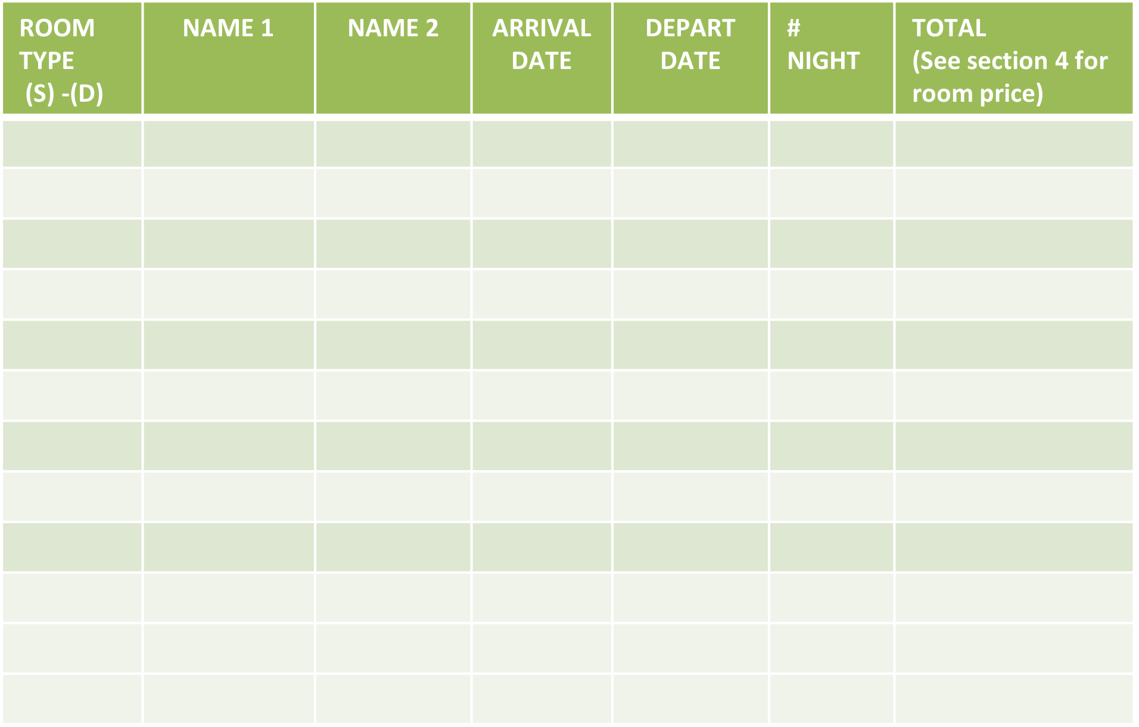

**Federation: ________________________**

**Hotel:___________________ Contact Name:______________________________**

**Room Type: Single(S), Double(D), Contact email: _______________________**

**HOTEL RESERVATION FORM**

**Grand Total** ____________

FORM MUST BE SENT TO: **grandprixcancun17@mgoevents.com**

NO LATER THAN **MAY 19, 2017** – FINAL RESERVATIONS MUST BE RECEIVED BY **JUNE 2, 2017-**  FULL PAYMENT MUST BE RECEIVED BY **JUNE 5,2017**

All Payments must be in USD no other currency will be accepted.

IF PAYING BY BANK WIRE – FUNDS MUST BE CONFIRMED BY ORGANIZERS BY **JUNE 6 -**  OTHERWISE PAYMENTS ARE REQUIRED UPON ARRIVAL

**CANCUN GRAND PRIX 2017, MEXICO**

*Form B*